**Ideation Phase**

**Empathize & Discover**

|  |  |
| --- | --- |
| Date | 11 October 2022 |
| Team ID | PNT2022TMID12047 |
| Project Name | Project - Car Resale value Prediction |
| Maximum Marks | 4 Marks |

**Empathy Map Canvas:**

An **empathy map** is a collaborative visualization used to articulate what we know about a particular type of user. It externalizes knowledge about users in order to 1) create a shared understanding of user needs, and 2) aid in decision making.

Visualizing user attitudes and behaviors in an empathy map helps UX teams align on a deep understanding of end users. The mapping process also reveals any holes in existing user data.

EXAMPLE

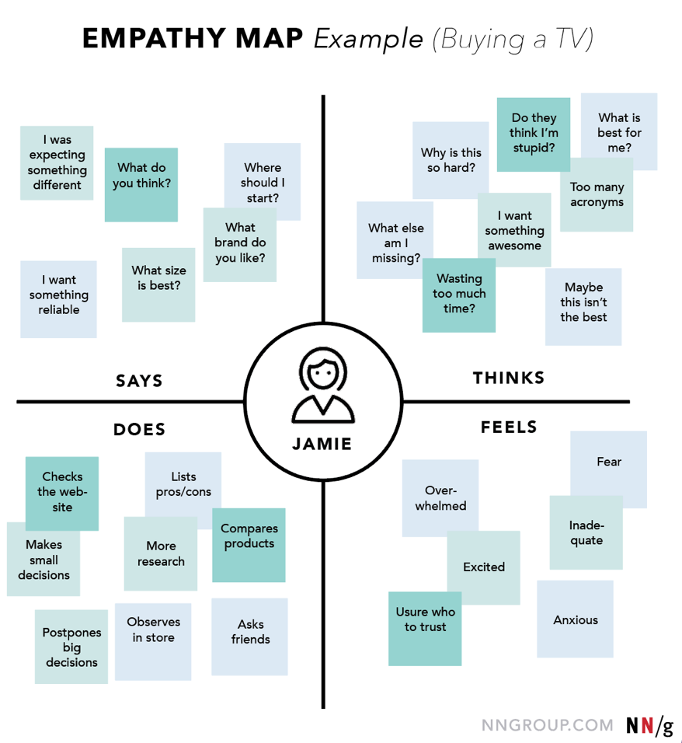

**Car Resale value Prediction**

